FIN 254 TVM – FORMALUE MzF
Future Value - single amounts
FV = PV (1 + i)^{n}
FV = PV (FVIF _{i, n} )
Present Value - single amounts
PV = FV / (1 + i)^{n}
PV = FV (PVIF _{i, n} )
Future Value – annuity
FVA = PMT (FVIFA _{i, n} )
FVA = PMT X (1 + i)^{n} - 1
i
Present Value – annuity
PVA = PMT (PVIFA _{i, n} )
_1__
PVA = PMT 1 - (1 + i)^{n}
i
Present Value of a Perpetuity
PVA = PMT
i
Future Value - annuity due
FV = PMT (FVIFA _{i, n} ) (1 + i)
Present Value - annuity due
PV = PMT (PVIFA _{i, n} ) (1 + i)
Mixed streams of cash flows
A series of single amounts – same formulae
Annual Percentage Yield (APY)/ EAR
APY = ( 1 + quoted rate ) ^{m} - 1
m

Present value of a bond

V_{B} = INT(PVIFA _{Kd, n)} ₊ M(PVIF _{kd, n}) one payment/yr
V_{B} = INT(PVIFA _{Kd/2, 2n)} ₊ M(PVIF _{kd/2, 2n}) semiannual

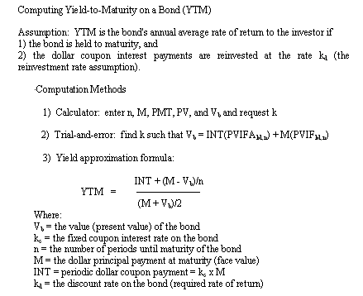

PREFERRED STOCK VALUATION
- A preferred stock can usually be valued like a perpetuity:

- Expected Rate of Return on Preferred stock

EXAMPLE (PREF. STOCK)
Xerox preferred pays an 8.25% dividend on a $50 par value.
Suppose our required rate of return on Xerox preferred is 9.5%.

If we know the preferred stock price is $40, and the preferred dividend is $4.125, the expected return is:

COMMON STOCK VALUATION

SINGLE HOLDING PERIODS
You expect XYZ stock to pay a $5.50 dividend at the end of the year. The stock price is expected to be $120 at that time.
If you require a 15% rate of return, what would you pay for the stock now?

Solution:
Vcs = (5.50/1.15) + (120/1.15)
= 4.783 + 104.348
= $109.13
MULTIPLE HOLDING PERIODS
- Constant Growth Model
Assumes common stock dividends will grow at a constant rate into the future.

- D₁ = the dividend at the end of period 1.
- k_{cs} = the required return on the common stock.
- g = the constant, annual dividend growth rate.

EXAMPLE (COMMON STOCK)
- XYZ stock recently paid a $5.00 dividend. The dividend is expected to grow at 10% per year indefinitely. What would we be willing to pay if our required return on XYZ stock is 15%?

D₀ = $5, so D₁ = 5 (1.10) = $5.50

Expected Return on Common Stock

We know a stock will pay a $3.00 dividend at time 1, has a price of $27 and an expected growth rate of 5%.

