FIN 440 LECTURE 10 & 11
CAPITAL BUDGETING
CHAPTER REFERENCE – CHP 9 & 10

Q. WHAT IS CAPITAL BUDGETING

KEYWORDS

- CAPITAL EXPENSES vs. FIXED ASSET OUTLAYS

- THE STEPS IN THE CAPITAL BUDGETING PROCESS

- MUTUALLY EXCLUSIVE vs INDEPENDENT PROJECTS

- CAPITAL RATIONING vs. UNLIMITED FUNDS

- ACCEPT-REJECT vs. RANKING APPROACH

THE CAPITAL BUDGETING CASHFLOWS

OPERATING CASH FLOWS

INITIAL INVESTMENT TERMINAL CASH FLOW

- CONVENTIONAL vs. NON-CONVENTIONAL CASH FLOWS

- MARGINAL ANALSIS

AFTER TAX TREATMENT OF SALE OF ASSETS

CAPITAL GAIN TAX

MARKET
PRICE

RECAP. DEPR. TAX

BOOK PRICE
TAX LOSS

(ALL OF THESE TOPICS WILL BE DISCUSSED IN DETAIL DURING CLASS – PLEASE REMEMBER TO CONSULT YOUR LECTURE NOTES WHEN REVIEWING – THIS LECTURE SHEET IS A SUMMARY OF IMPORTANT POINTS)
CAPITAL BUDGETING TECHNIQUES

- NET PRESENT VALUE (NPV)

DECISION CRITERIA

IF NPV IS POSITIVE – ACCEPT

IF NPV IS NEGATIVE - REJECT
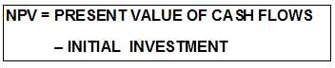

- INTERNAL RATE OF RETURN (IRR)

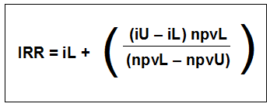
DECISION CRITERIA

IF IRR > cost of capital – ACCEPT

IF IRR < cost of capital - REJECT

- MODIFIED INTERNAL RATE OF RETURN (MIRR)

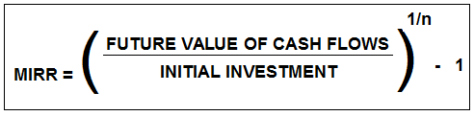
DECISION CRITERIA

SAME AS IRR

- PROFITIBILITY INDEX (PI)
(also known as PIR & VIR)

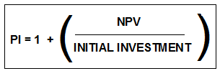
DECISION CRITERIA

IF PI > 1 – ACCEPT

IF PI < 1 - REJECT
DECISION CRITERIA

IF NPV IS POSITIVE – ACCEPT

IF NPV IS NEGATIVE - REJECT

